Throughout this first chapter we have explored the idea of Canadian Identity and what it might mean to be Canadian. For the first assignment of the year you are to reflect on what you believe to be the important elements of Canadian Identity and create a piece of artwork to represent these images.

For this assignment you will have two options.
- Create a poster or collage of words and phrases that you think are essential to Canada’s identity
- Write a paragraph or poem that summarizes your views of Canada’s identity.

Grading:
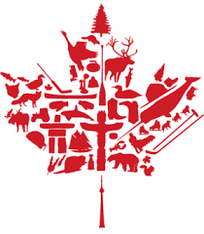
These assignments will be graded on content, appropriateness of the images/references, and effort/quality. Please take time to color and refine your work as they will be displayed in the classroom.
Element | Value
Content | /5
References | /3
Effort/Quality | /2
Total | /10

