What Does “Identity” Mean?
- Identity: _______________________________________________________________________
________________________________________________________________________________
- Do the images below portray any identities?
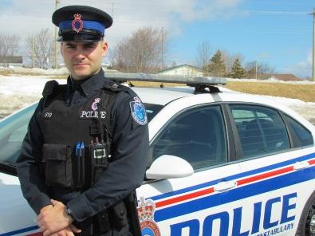
Image 1: Associated Identity:
____________________________________________________________
____________________________________________________________
____________________________________________________________

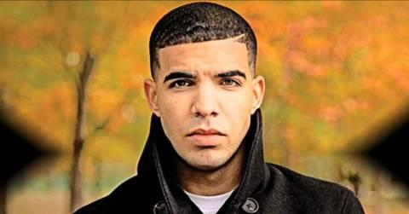
Image 2: Associated Identity
_________________________________________________________
_________________________________________________________
_________________________________________________________
Who am I?
- Before thinking about a _________________ it is important to think about your _____________.
- Your own identity is made up of factors including; ____________________________________
________________________________________________________________________________
Create a concept web in your notebook with “Who am I” at the centre. Write or draw your ideas about your own identity on the concept web

Who Am I?

What is Canadian?
- To determine what a Canadian identity might look like we need to determine _______________________.
- Lets do a short brainstorm activity.
- With a partner list everything that comes to mind when you hear the word “Canadian”.
Canadian

How Do We Examine Canadian Identity?
- To examine the concept of Canadian identity we can look at several sources:
  - __________________
  - __________________
  - __________________
  - __________________

Examining Identity: Activity:
Song 1: Hockey Song – Stompin Tom Connors
- What are some dominant images from this song?

- Does this song relate to your own identity? Explain.

- What does this song contribute to your idea of a Canadian identity?

Artwork 1: Painting: “Whales of Monterrey” Ted Harrison
- What is the subject of this painting?

- What feature in this painting stands out the most?

- How does this painting impact your views on a Canadian identity?

Video 1: Historica Minutes: Chanie Wenjack
- How is this video linked to Canada?

- Why were residential schools created?

- How does this video make you feel about the history of Canada?

Artwork 2: Sculpture: Wait for Me Daddy
- What elements are visible in this sculpture?

- What do you feel are the most striking features of this sculpture?

- How is this sculpture linked to Canada?

Types of Identity: National
Factors contributing to the creation of national identity (LARGE SCALE IDENTITY)
-______________________
-Community
-______________________
-Personal and collective histories and traditions
-________________________________________
-Belief in peace, justice, freedom, equality, and rights
-_______________________________________
Types of Identity: Personal
Factors contributing to the creation of personal Identity (SMALL SCALE IDENTITY)
- _______________________________________
- Your family and friends
- _______________________________________
- your ethnicity
- _______________________________________
- Your values
So, Who Are We?
Surface area: _____________ largest in the world
Population: ~________________________
Canadian Population Clock: http://countrymeters.info/en/Canada
Official languages: __________________________________
National Capitol: __________________________________
Date of Confederation: ______________________
- The creation of a federal Dominion of Canada joining the previously existing provinces into a nation (semi-independent from the Crown (on internal matters only))
- Brought together the provinces of _______________________________________________________
______________________________________(the provinces we know today as Ontario and Quebec)-
Canada 2015: ________ provinces, ______ territories
Canadian Creation
The Fathers of Confederation (36 in total):
- ___________________________________ (first Prime Minister)
- Sir George- Etienne Cartier
These men were the original founders of Canada
The British North American Act (BNA Act)
- The fathers of confederation wrote a constitution (document indicating the highest form of law) outlining what Canada should look like/how it should be run (i.e. laws, division of power between the provincial and federal governments, etc.)
- This constitution had to be passed by British Parliament as we were still a British colony governed by the Brits
- The rest of Canada’s provinces and territories joined Confederation (became a part of the country) at later dates:
- 1867 _________________________________________
- 1870 Manitoba, Northwest Territories
- 1871 __________________________________________
- 1873 Prince Edward Island
- 1898 Yukon Territory
- 1905 Alberta, Saskatchewan
- 1949 Newfoundland and Labrador
- 1999 _______________________________________

Our Prime Minister: _______________________________________

Our Governor General:_____________________________________

Some Key Words
Culture: ______________________________________________
_____________________________________________________

Multiculturalism: ______________________________________________
_____________________________________________________

Mosaïc: ______________________________________________
_____________________________________________________

Ethnicity:______________________________________________
_____________________________________________________

Nation: ______________________________________________
_____________________________________________________

Nationalism:____________________________________________
_____________________________________________________

