- A climograph is used to represent the climate of a place, as it changes across months
- A climograph has one horizontal axis and two vertical axes.

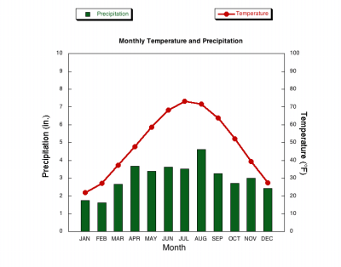

- The vertical axes are used to show
  - Average precipitation, i.e. rain and snowfall, on the left
  - Average temperature on the right (in Celsius or Fahrenheit)

Draw two climographs using the data collected for both St. John’s and Iqaluit. Then, compare and contrast both graphs using the comparison chart and guiding question.
(NOTE: When constructing graphs that will be compared it is most useful to use the same scale on both graphs)

St. John’s Data: 47.5615° N
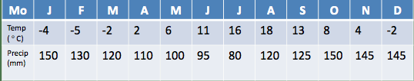
Winnipeg’s Data: 49.8951° N
 | Jan | Feb | Mar | Apr | May | Jun | Jul | Aug | Sep | Oct | Nov | Dec
Temp | -18 | -15 | -10 | 0 | 8 | 12 | 18 | 17 | 13 | 5 | -5 | -15
Precip | 22 | 18 | 23 | 38 | 60 | 82 | 75 | 75 | 50 | 35 | 25 | 20

Location | Max Temp (°C) | Min Temp (°C) | Temp Range (°C) | Max Precipitation (mm) | Min Precipitation  (mm) | Total Precipitation  (mm)
St. John’s
Iqaluit

What are some differences you notice between the two climographs?
__________________________________________________________________________________________________________________________________________________________________________________________________________________________________________________________________________________________________________________________________________________________________________________________________________________
Locate St. Johns and Winnipeg on a map. Given the two locations what factors would cause the difference in the climate in the two cities?
__________________________________________________________________________________________________________________________________________________________________________________________________________________________________________________________________________________________________________________________________________________________________________________________________________________________________________________________________________________________________________________________________________________________________________________________________________________

