- Complete the following table. Use the table to color and label the map on the next page.
Canada: Regional Attributes
Region | Location (Provinces Included) | Attributes | Color on Map
Atlantic Canada
Quebec
Ontario
Prairies
British Columbia
Canadian North

- Plot the following cities on the Map that you have created using the key below.
Main Industry |  | Symbol
 |  | Population
 |  | 0-500000 | 500000- 1 million | More than 1 million
Primary (Mining, Agriculture, Energy)
Secondary (Manufacturing)
Tertiary (Business, Trade, Government, Retail, Health Care, Social Assistance)
City | Main Function | Population
Toronto | Business Service | 5 741 400
Montreal | Retail | 3 859 300
Vancouver | Retail | 2 391 300
Calgary | Energy | 1 242 600
Ottawa-Gatineau | Government | 1 239 100
Edmonton | Finance and Real-estate | 1 176 300
Quebec | Government | 754 400
Winnipeg | Retail Trade | 753 600
Hamilton | Manufacturing | 740 200
Kitchener-Cambridge-Waterloo | Manufacturing | 492 400
London | Retail | 492 200
St. Catharines-Niagara | Business Service | 404 400
Halifax | Health care and social assistance | 403 200
Oshawa | Retail | 364 200
Victoria | Government | 358 100
Windsor | Manufacturing | 330 900
Saskatoon | Energy/Agriculture | 265 300
Regina | Energy/Agriculture | 215 100
Sherbrooke | Health care and social assistance | 197 300
St. John’s | Government and health care | 192 300

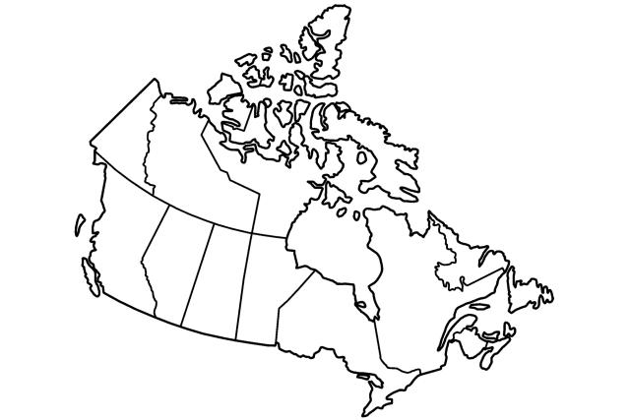
Canada’s Regions

