Urban and Rural Areas
- This chapter looks at the effect that a person’s ______________________ has on their identity.
- Communities can be broken into two different categories.
  - UrbanCommunity: ________________________________________________________ ________________________________________________________________________
  - Rural Community: _________________________________________________________
________________________________________________________________________
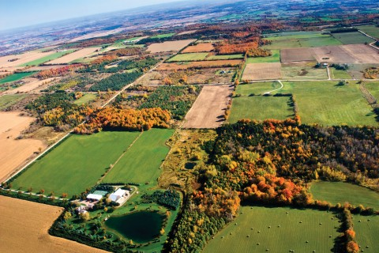
Would you describe this image as rural or urban? Why?

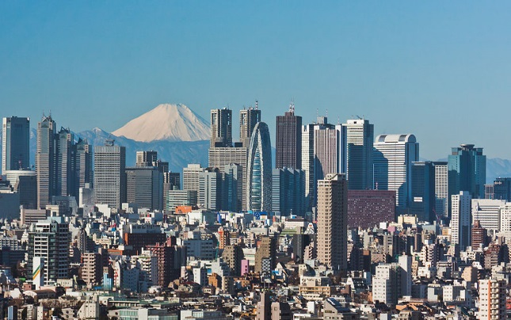
Would you describe this image as rural or urban? Why?
Canada’s Human Landscape
- When describing populations we will use three important terms.
  - __________________________________
  - __________________________________
  - __________________________________
Population Distribution
- Population distribution: ___________________________________________________________ ______________________________________________________________________________
  - Concentrated or Dispersed
  - In the table below construct a representation of a concentrated population and a dispersed population
Concentrated Population | Dispersed Population

Archipelago Effect
- Archipelago effect: ______________________________________________________________ ______________________________________________________________________________
Construct an image that represents the archipelago effect in the box below:
Population Density
- Population density: ______________________________________________________________ ______________________________________________________________________________
Population Density = Population /Area
Calculate the population density of a country with an area of 13000000km2 and a population of 36 million people

Site and Situation
- When studying location an growth of towns an cities geographers divide factors that determine the location of human settlements into two main categories
- Site factors: _________________________________________________________________.
  - ________________________ ________________________________
  - ________________________ ________________________________
- Situation factors: _____________________________________________________________.
  - _______________________ __________________________
  - _______________________ __________________________
- What site and situation factors led to the growth of St. Johns?

Settlement Patterns
- The relocation of first nations:
  - When _________________ first came to Canada they were attracted to the land the _______________________ were inhabiting
    - ________________________________ factors there provided the best _____________________________.
  - Long-term contact between Europeans and First Nations almost always led to the relocation of the ______________________.
  - Europeans continued to take favorable lands, relocating the First Nations to areas that were ______________________, and with ____________________________________
- Atlantic Canada:
  - People _________________where they could
    - PEI, Annapolis Valley, Cape Breton.
  - Mostly people settled near the ocean so they could ____________
- New France:
  - Settlers wanted to be close to the _______________________
  - It was the major system of _____________________, and source of ________________.
  - Settlement formed in the _____________________________________
  - Seigneurial System: _______________________________________________________ __________.
- Ontario:
  - The ____________________ settled Ontario where they adopted the Township system.
  - Township System: _________________________________________________________
  - The size of lots gradually ____________________________ due to the use of __________________.
- The Prairies
  - Land was divided into _________________________.
  - Like Ontario but the grid was much______________________.
  - Sections: ________________________________________________________________ ________________________________________________________________________
  - Sections were divided into quarter sections
- The North:
  - Settlements formed around _______________________________________
    - Gold
- British Columbia:
  - Settlement formed in _____________________________________________________ _______________________________________________________________________
  - Trees, mining, rivers
  - The Fraser River delta seen__________________________________ develop.
Growth And Decline
- The growth of Canada is heavily influenced by Geography
- Regional factors determined how the different parts of Canada would grow.
Growth
- Atlantic Canada:
  - No large _________________________________ activities
  - Developed due to ________________________________________________ industries.
  - This promoted the growth of _______________________________________________ _______________________________________________________________________.
- The West Coast:
  - The rugged mountains and coast promoted ___________________________________.
  - Farming was only possible in _____________________________________.
  - Settlements grew along the _____________________ and in ____________________.
- Great Lakes –St.Lawrence
  - Most of Canada’s ____________________________________ grew in this area
  - _______________________________________________________________________________________________________________________________________________.
  - Farms grew, and with that growth so did the industries that supported farming.
Decline
- 1881 _______________ of Canadians lived in rural settlements
- Rural: ___________________________________________________________
- Most Canadians were involved in _____________________________________ activities
  - __________________________________________________________________
- This all began to change in the 1890’s and early 1900’s
- Industrial revolution: _____________________________________________________________ ______________________________________________________________________________
- Towns in Ontario and southern Quebec became _______________________________________
- Fueled by railway, coal and steel
- More people moved to urban areas
- Urban: ___________________________________________________________________________________________________________________________________________
- Rural to Urban Shift: _____________________________________________________________ _____________________________________________________________
- By the 1940 less than half of Canadians lived in rural areas.
- Urbanization: __________________________________________________________________________________________________________________________
- Towns based only on _____________________________________are disappearing.
- As population goes down, serviced decrease, and more people leave to find better services

Canada’s Regions
- Regional Analysis: __________________________________________________________________________________________________________________________
- The characteristics of regions can be divided into four categories
  - Location:_________________________________________________
  - Physical and cultural characteristics: __________________________.
  - Political perspective: ______________________________________.
  - Hierarchy: _______________________________________________.
Canada’s Political Regions
- Canada’s has five political regions
  - ________________________________________
  - ________________________________________
  - ________________________________________
  - ________________________________________
  - ________________________________________
- The regions are based on the characteristics of regions listed previously.
- They are useful when discussing different areas of Canada
Atlantic Canada
- Location:
  - ________________________________________________________
- Physical and Cultural Features:
  - ________________________________________________________
  - ________________________________________________________
  - ________________________________________________________
- Politics:
  - Connected to ______________________________________ (USA)
  - Debate on __________________________________________
- Hierarchy
  - _____________________________________________ (Cape Breton, Labrador, Southern Shore)
Central Canada
- Location:
  - _____________________________________________
- Physical/Cultural Attributes:
  - ________________________________________________________
  - ________________________________________________________
  - ________________________________________________________
  - ________________________________________________________
- Politics:
  - ________________________________________________________
- Hierarchy
  - ________________________________________________________
The Prairies
- Location:
  - ________________________________________________________
- Physical/Cultural Attributes:
  - ________________________________________________________
  - ________________________________________________________
  - ________________________________________________________
- Politics:
  - Strong ties to USA due to _____________________________________________
- Hierarchy:
  - Oil patch
British Columbia
- Location:
  - __________________________________________________
- Physical/Cultural Attributes:
  - _____________________________________
  - _____________________________________
  - _____________________________________
- Politics:
  - Connected to US west coast.
  - Economic ties to Asia
- Hierarchy:
  - Local regions in the interior and on Vancouver Island
The North
- Location:
  - ________________________________________________________
- Physical/Cultural Attributes:
  - Predominantly _____________________________________________________
  - Forest in the West_______________________________________ in the East
  - Resource based economy
- Political Perspective:
  - Territories of the Federal government
- Hierarchy:
  - ___________________________________________
  - Eastern Arctic
  - Yukon
The Core and the Periphery
- Interaction among the 5 regions is a key factor in investigating the growth and prosperity of Canada.
- A tool that geographers use to understand this relationship is the concept of _____________________________________________ and the relationships that develop between them.
Core
- The core is _______________________________________________________________________________________________________________________________________. Toronto is an example of a core.
- Over half of Canada’s population lives in ___________________________ ___________________________________.
Periphery
- The periphery is ________________________________________________________________. It is sometimes referred to as the “hinterland”.
- It supplies _____________________________________________, and provides a ________________________________ for its manufactured products and services.
Windsor-Quebec City Corridor
- Over time, this corridor became the centre of Canada’s financial services and the hub of ___________________________________________________________.
- This area sends more Members of Parliament to Ottawa. Why? What affect does this have?
3.4 Regional Identities
- Many _____________________________ are associated with ___________________________. What industries and identities are depicted below?
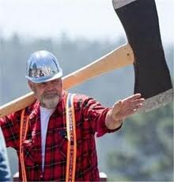
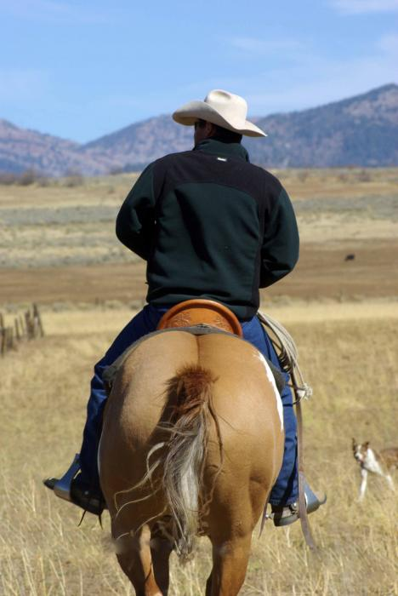
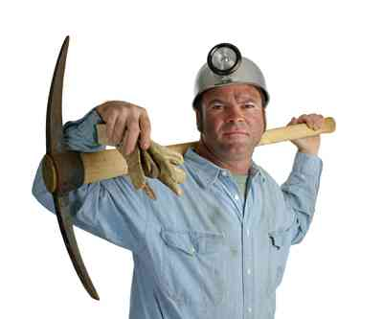

___________________ _______________________ ___________________
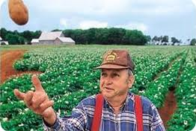
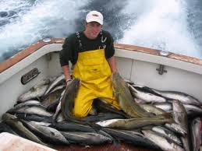

________________________ __________________________

Regional Identities and Stereotypes
You are a Newfoundlander. Therefore you must...
Jig for cod? Dance the jig? Eat fish and brewis or flipper pie? Row a dory? Drink Screech? Live in a saltbox? Go mummering at Christmas? Play the fiddle or button accordion?
A stereotype is an______________________________________________ ___________________________________________________________________
Sometimes stereotypes are negative (as portrayed in “stupid Newfie” jokes) and can lead to a prejudiced view of a group.
Newfoundland Stereotypes
What stereotype of Newfoundlanders does the following video show?

