Identify as many of the following features as you can on the map below:
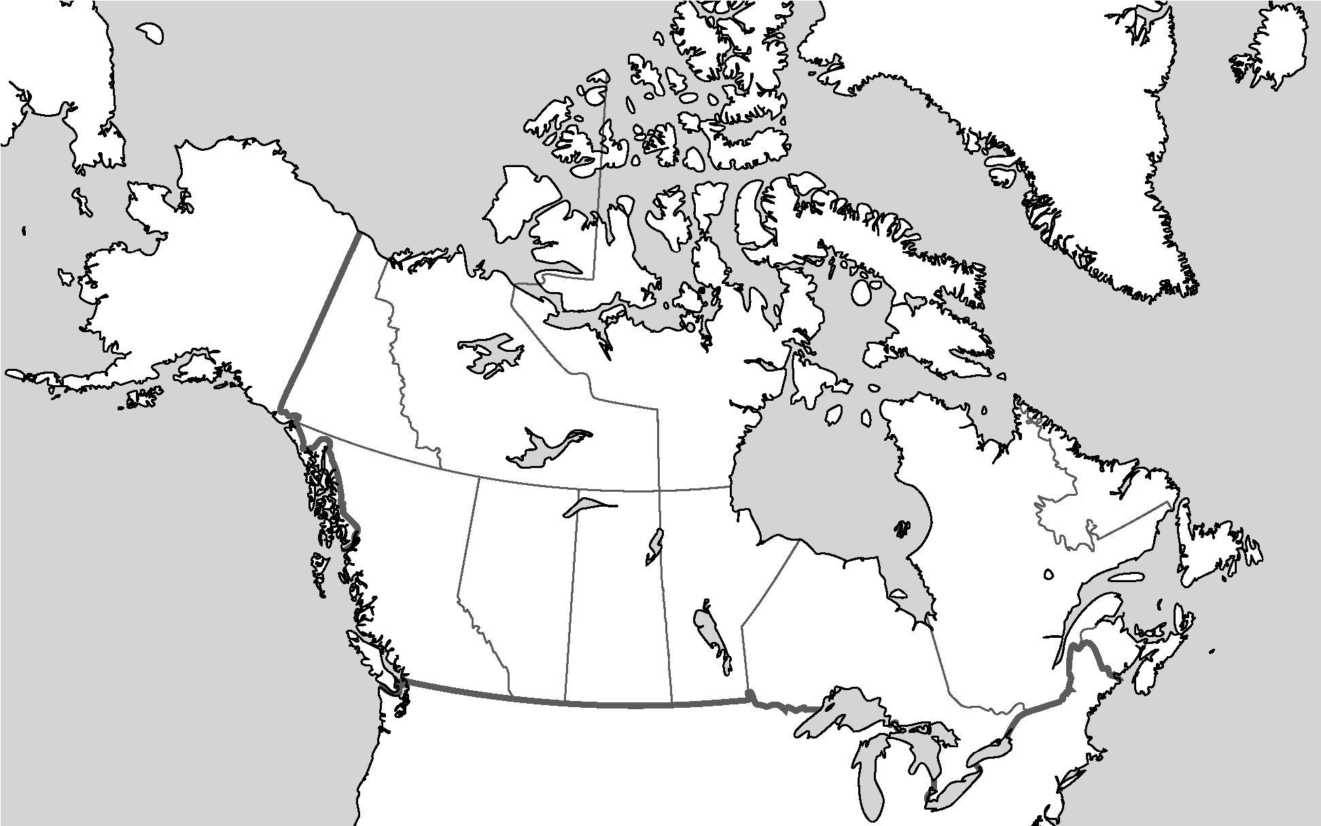
Provinces, Capital Cities, Rivers, Lakes, Oceans, Seas, Bays Countries, other points of interest.

In a paragraph respond to the following prompt:
“Being Canadian means…”

